Sample IOS Project

1. Extract SertaintyIOS.zip
2. Start XCode

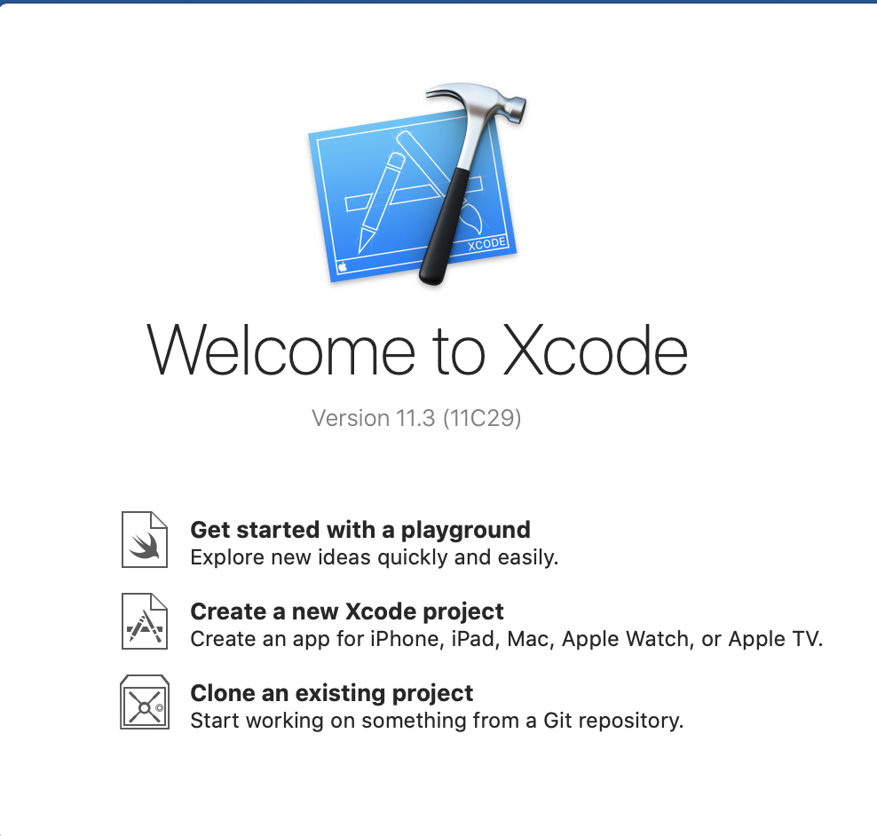

1. Create New XCode Project

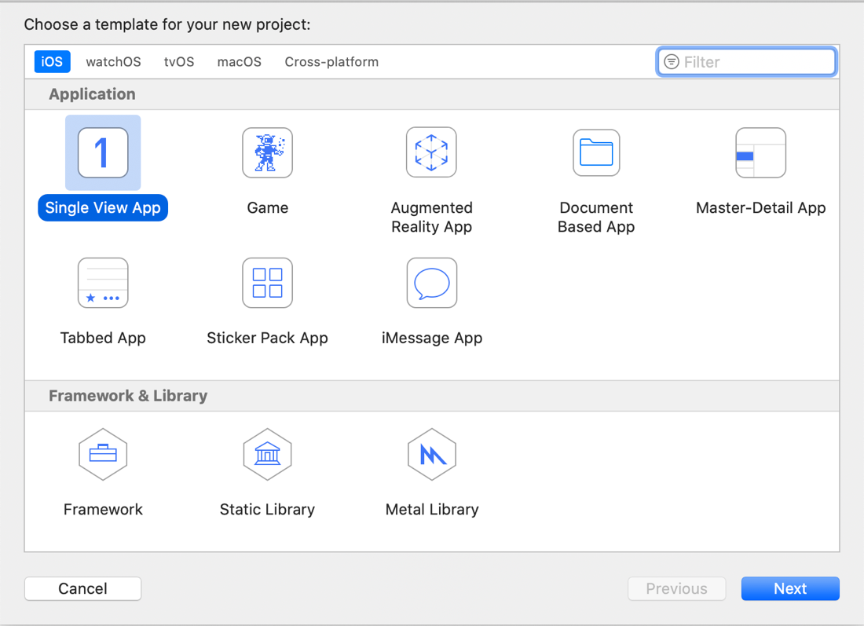

1. Single View App

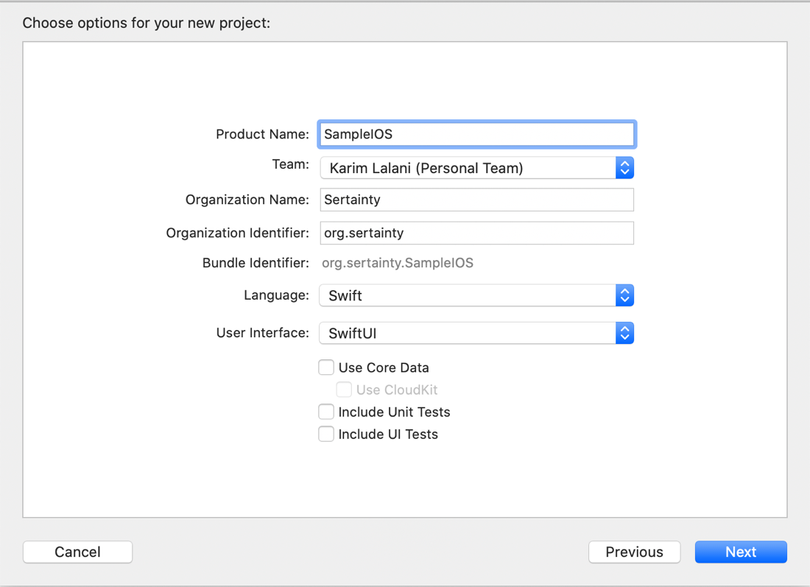

1. Set language to Swift and user interface to SwiftUI

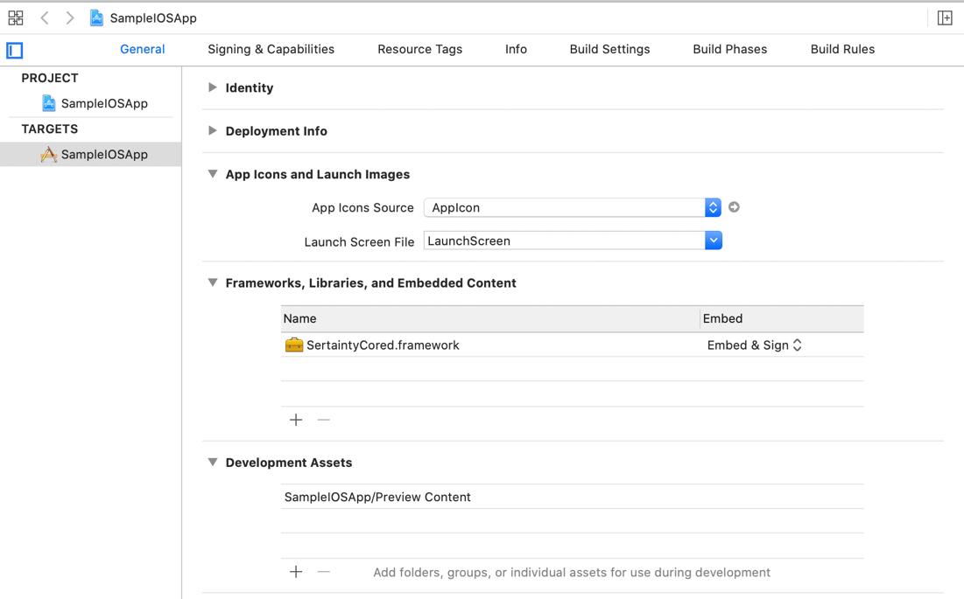

1. In General Settings, Framework, Libraries, and Embedded Content, add framework – SertaintyCore.framework

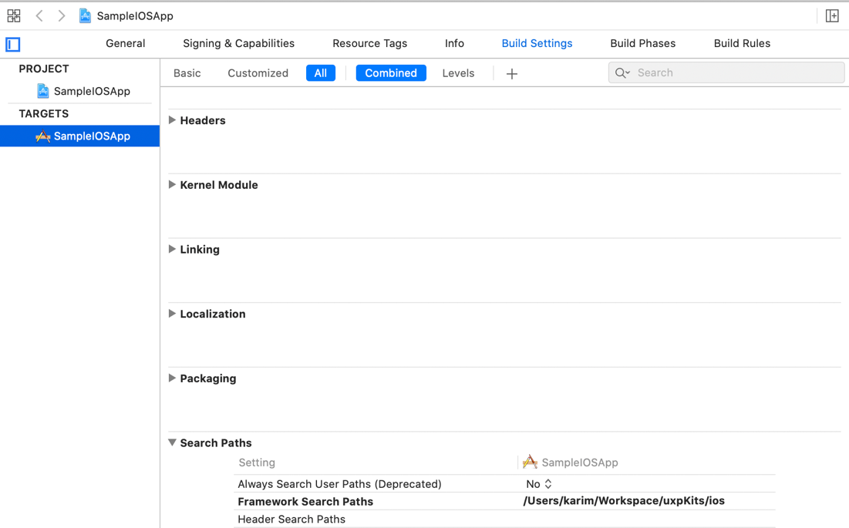

1. Go to Build Settings > Framework Search Paths > Set to folder where framework is

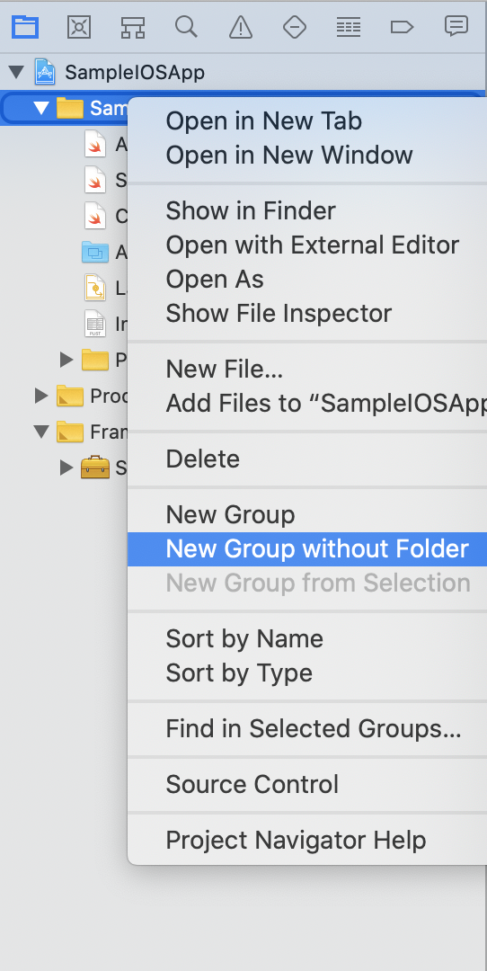

1. In the Project Navigator > right click the Add New Group without Folder. Name it “Wrappers”

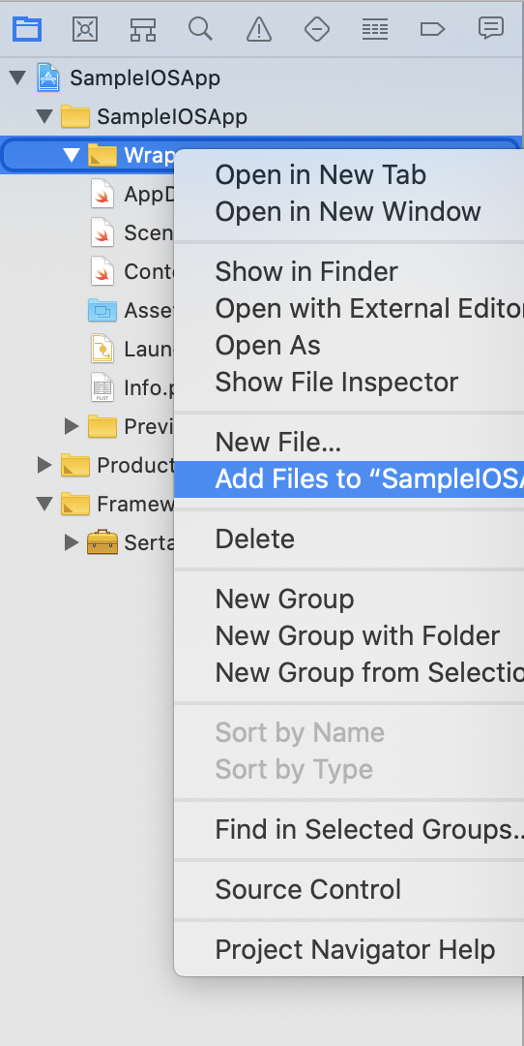

1. Right click “Wrappers” > click Add Files To … Browse and select all swift files from “SertaintyIOS>swift”
2. Delete AppDelegate.swift, SceneDelegate.swift, and ContentView.swift

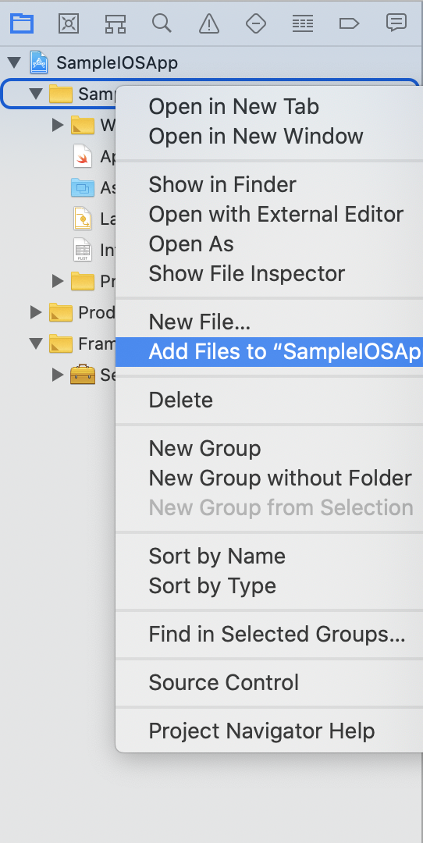

1. Right click Project Folder > click Add Files To … Browse and select all files from “SertaintyIOS>sample”

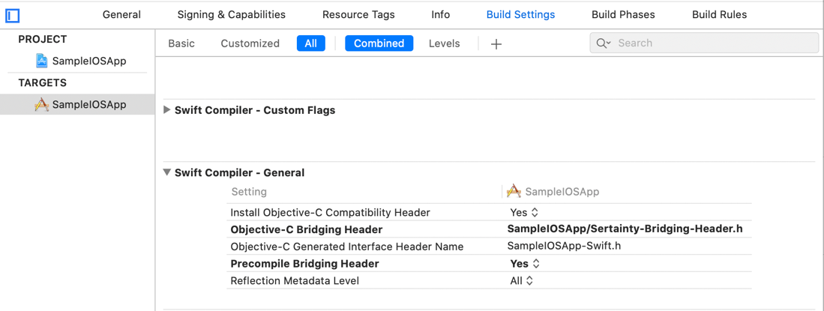

1. Go to Build Settings > Swift Compiler – General. Set “Objective-C Bridging Header” to “<AppName>/Sertainty-Bridging-Header.h”

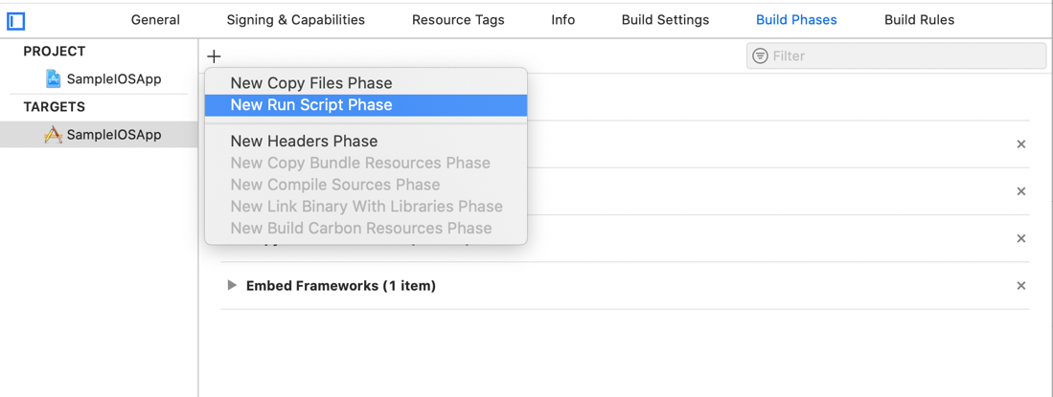

1. Go to Build Phases > Click + to add new phase > New Run Script Phase
2. Expand Run Script and paste below code there:

install_name_tool -change SertaintyCore.framework/SertaintyCore @executable_path/Frameworks/SertaintyCore.framework/SertaintyCore $TARGET_BUILD_DIR/$TARGET_NAME.app/$TARGET_NAME

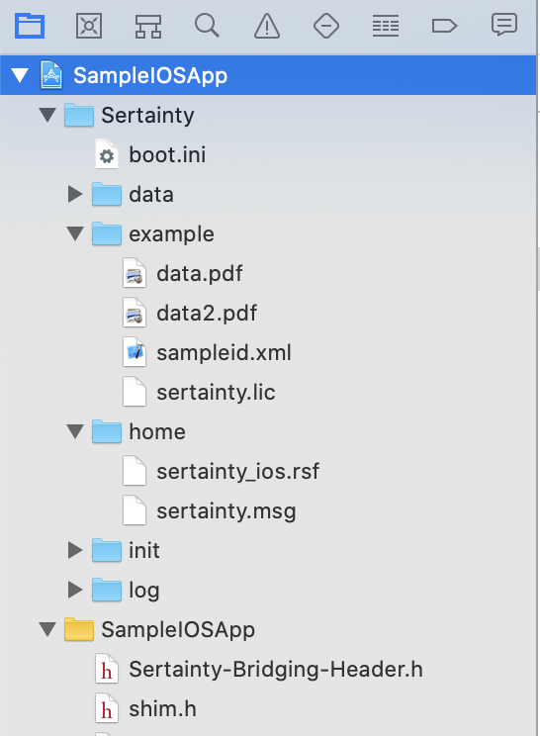

1. Rename an existing Sertainty license file “sertainty.lic” and copy it to SertaintyIOS>Sertainty>example folder.
2. Right click Project and click Add Files to … . Browse and select the SertaintyIOS>Sertainty folder.
3. Build and Run the program

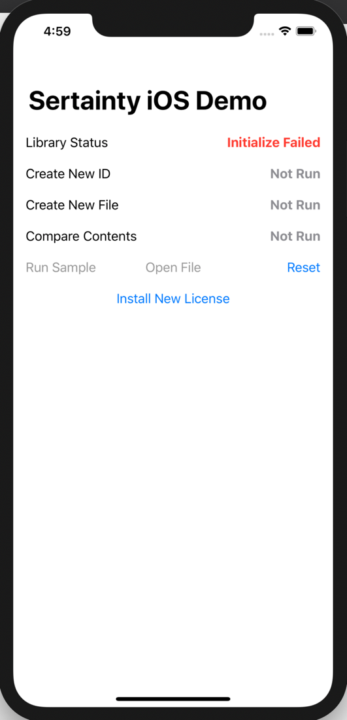

1. On first load, the app will show “Library Status” to “Initialize Failed”. This means the project setup was correct. This is normal. Click “Install License”

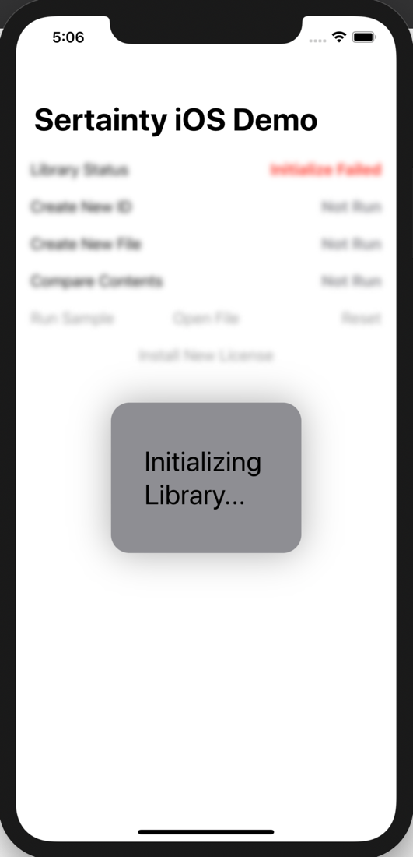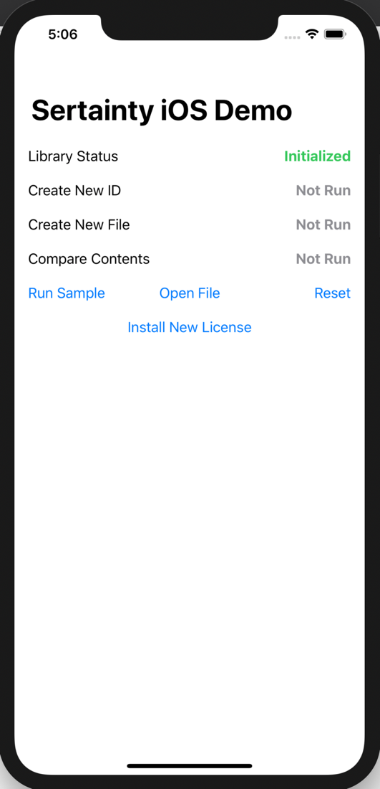

1. If license is valid, it will initialize and status will change accordingly. Click “Run Sample”. This will create a sample ID using the sampleid.xml, create a UXP using the new sample ID, add data.pdf and data2.pdf, compare contents, and save the UXP. You should see a prompt to save the file.

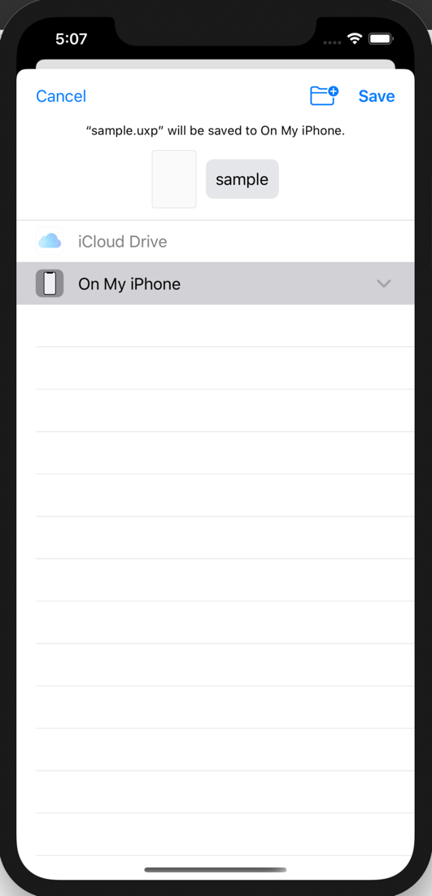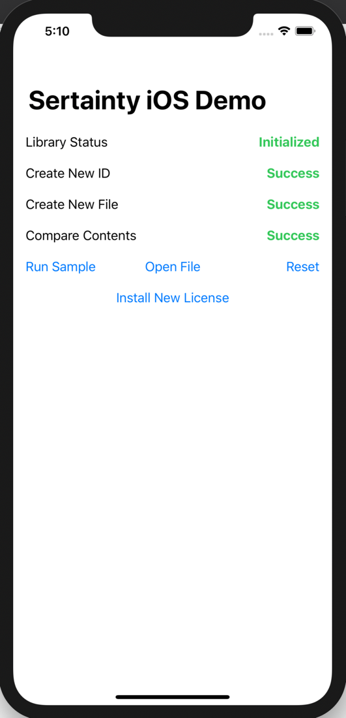

1. Click Save.